ICE

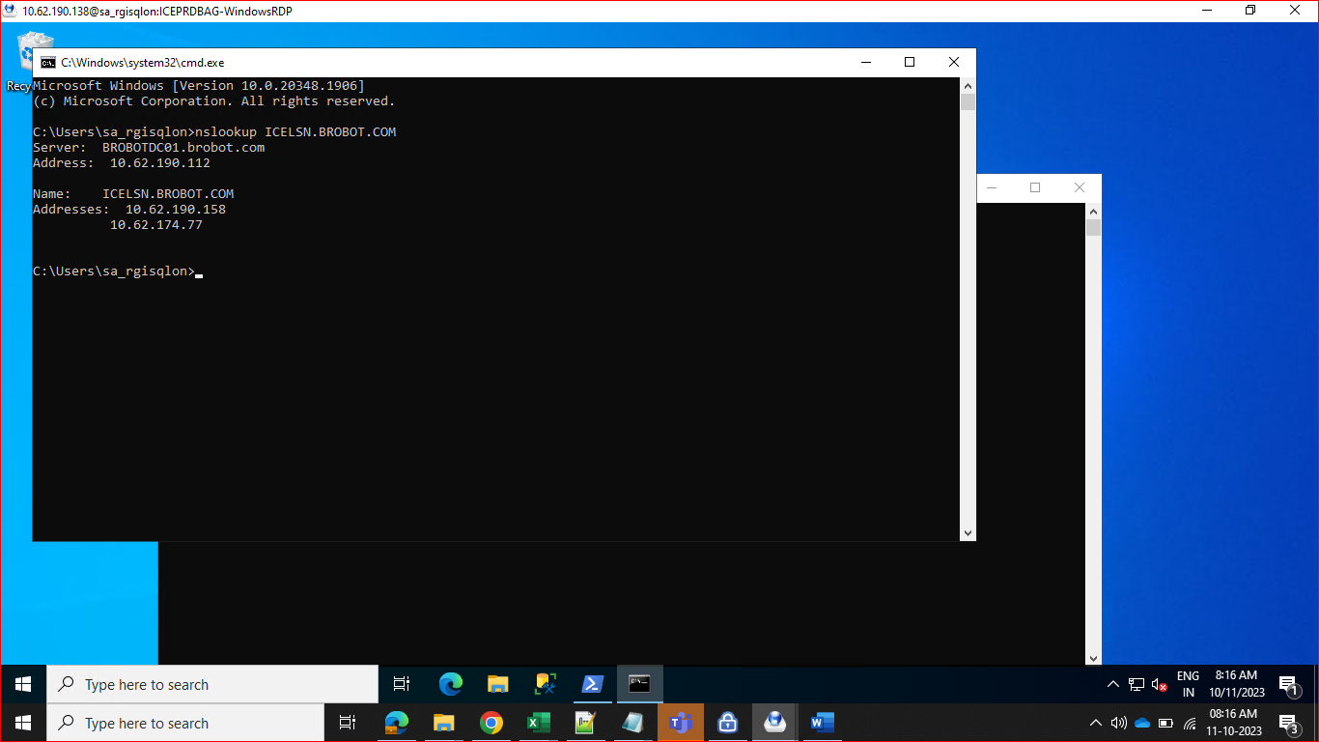

Import-Module FailoverClusters

Get-ClusterResource

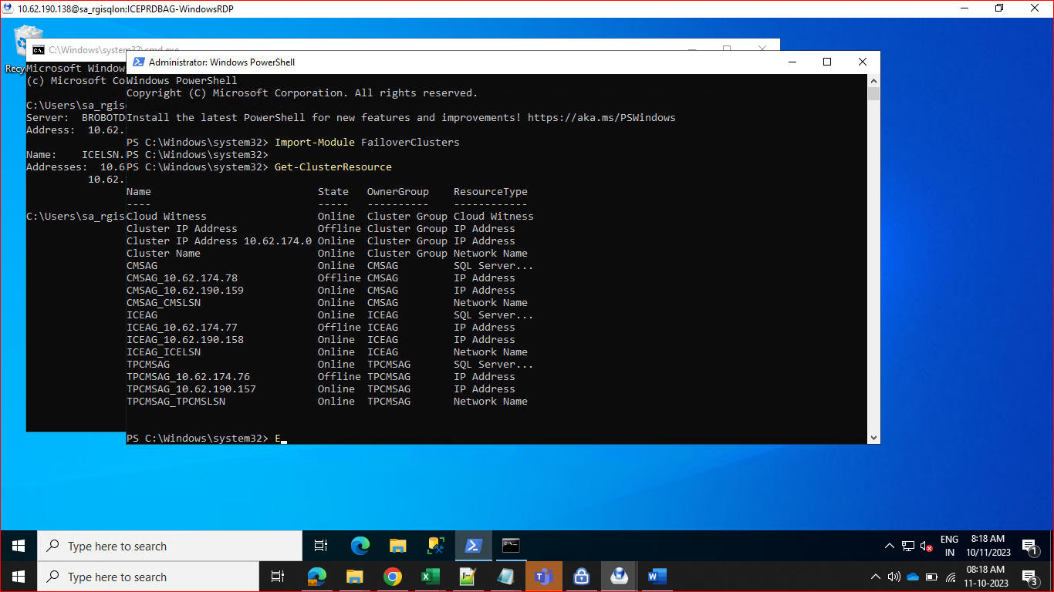

Get-ClusterResource ICEAG_ICELSN | Get-ClusterParameter RegisterAllProvidersIP

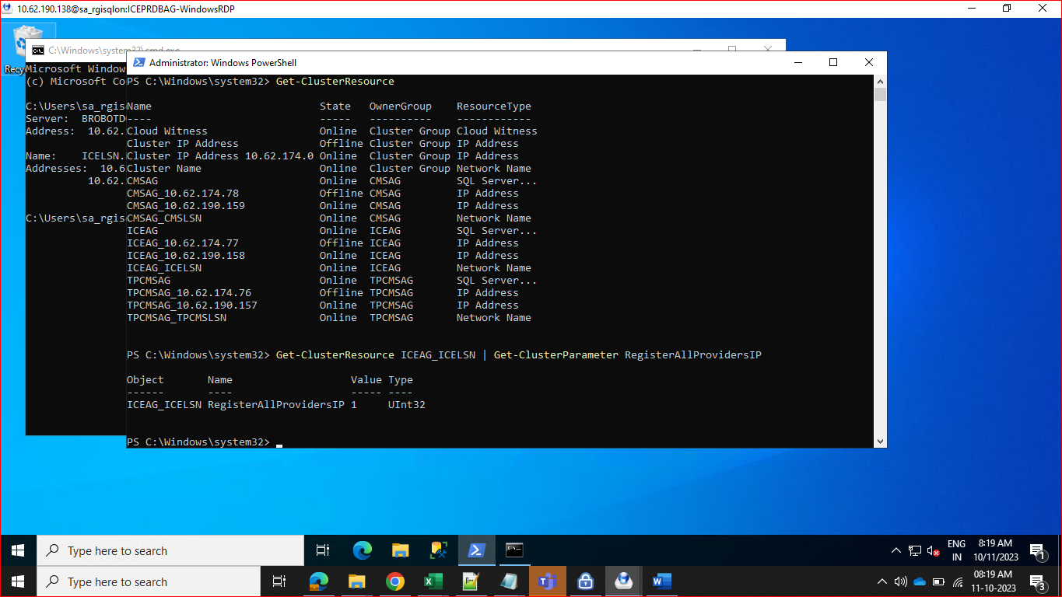

Get-ClusterResource ICEAG_ICELSN | Set-ClusterParameter RegisterAllProvidersIP 0

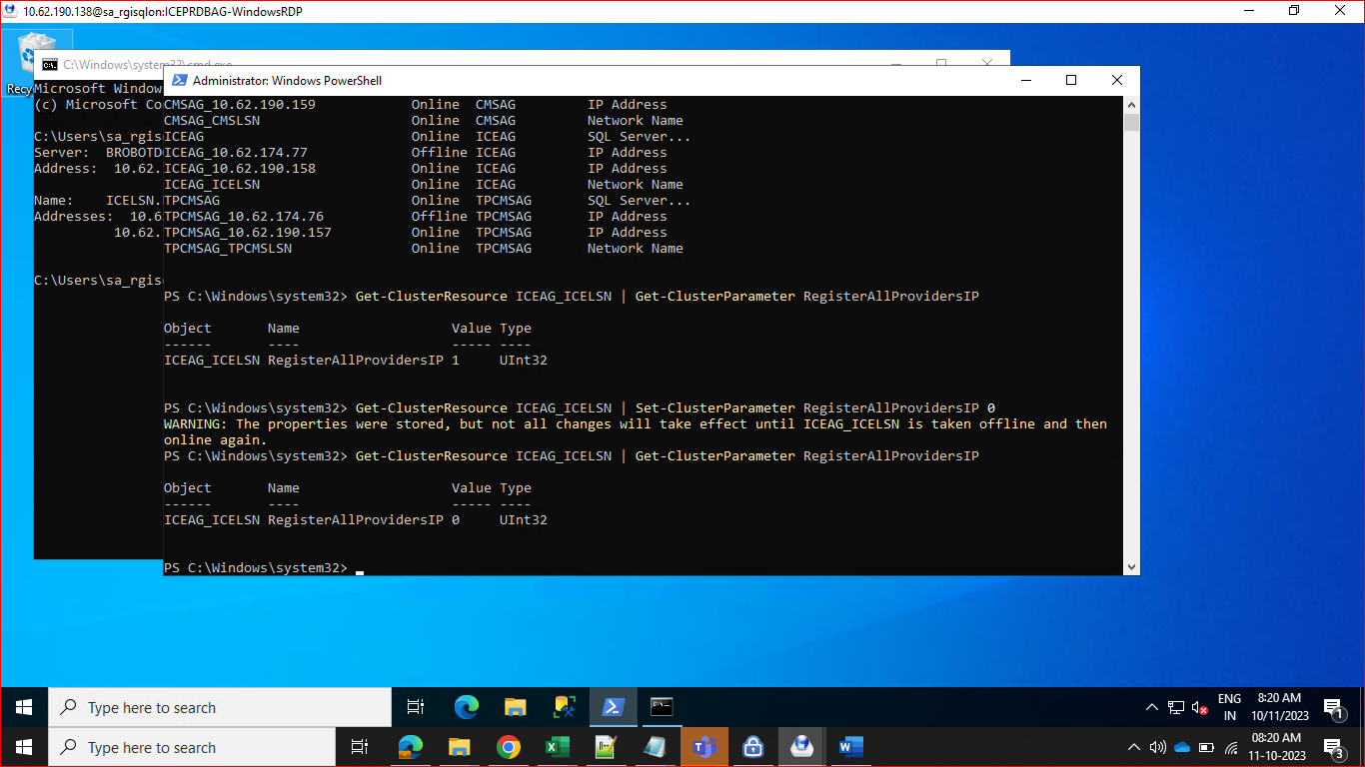

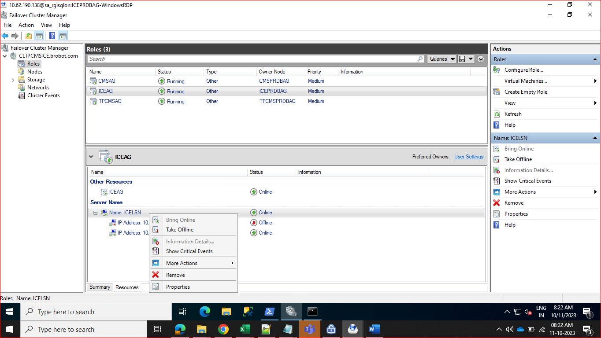

Take ICEAG offline and then online

